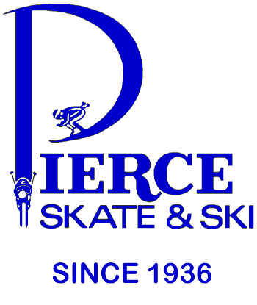 208 West 98th Street Bloomington, MN 55420 P-952.884.1990 www.pierceskateandski.com
Fall 2021 7X Midwest Regional Shop of the Year 1990/2002/2004/2008/2009/2012 & 2014

Dear MAST Members,

We are hopeful that our long-standing commitment to alpine ski racing over the past 40 years (see below), will give you pause to deal with us versus a dot.com or on-line provider who have provided zero support of the local race community.

*We have provided the local race community over $600,000 in financial support.
*We are the only shop in the U.S. that has been at Mt. Hood 23 of the past 24 summers conducting independent product testing.
*Since 1996: 25 of 26 Men’s & 22 of 26 Women’s State SL Champs have been Pierce customers.
*Question: What do Kristina Koznick, Tasha Nelson, Martina Sailer, Lindsey Vonn, Kaylin Richardson, Sterling Grant, Michael Ankeny, Matt Strand, Paula Moltzan, Isaiah Nelson & Camden Palmquist all have in common?
Answer: All were Pierce Skate & Ski customers before they were USST members

*Partnering with Pierce is your 1st step towards the podium!

MAST Equipment Night Wednesday October 6th from 4 PM to 9 PM
Come in and take advantage of our expert advice and tremendous savings. We are offering *25% to 40% DISCOUNTS OFF of suggested retail pricing on selected race product from ATOMIC, DYNASTAR, FISCHER, HEAD, LANGE, LEKI, MARKER, NORDICA, ROSSIGNOL & SWIX.
*Head Coach Mark Conway will be present to provide assistance & advice.
Please call 952-884-1990 and make an appointment.

Keep in mind that members and their immediate family receive a 15% discount off suggested retail price on most merchandise as well as special rates on ski tuning.

Bart, Terri & Tyler Pierce, Dave Hinz, Eric Jacobson, Liz Penny, Ted Petroskey and the rest of the Pierce Staff!

