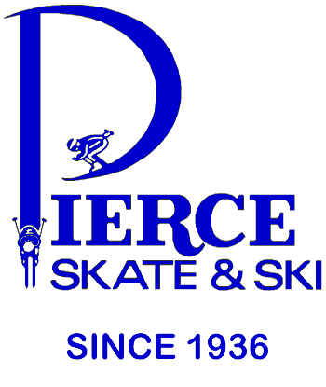 208 West 98th Street Bloomington, MN 55420 P-952.884.1990 www.pierceskateandski.com
Fall 2018 7X Midwest Regional Shop of the Year 1990/2002/2004/2008/2009/2012 & 2014

Dear MAST Members welcome back to our 83rd Winter Season!

Here are the Top 10 reasons you should partner with Pierce:
*For 35+ years Pierce has been dedicated to alpine ski racing in sales, service and support.
*We have given back to the local race community over $500,000 in financial support.
*We are the only shop in the U.S. that has been at Mt. Hood 21 years straight conducting independent product testing.
*We were the 1st shop in North America with the Montana Challenge stone grinding system.
*PREFERENTIAL PRICING on Race Prep & Binding Installation on skis purchased from us.
*The Pierce Staff is recognized as one of the best in the industry. Ski Industries of America has recognized us as the Midwest Ski Retailer of the Year a record setting 7th times.
*Warranty processing- On equipment we sell our record for handling claims is legendary.
*Since 1996: 22 of 23 Mens & 19 of 23 Womens State SL Champs have been Pierce customers.
*Question: What do Kristina Koznick, Tasha Nelson, Martina Sailer, Lindsey Vonn, Kaylin Richardson, Sterling Grant, Michael Ankeny, Matt Strand, Paula Moltzan & Isaiah Nelson all have in common?
Answer: All were Pierce Skate & Ski customers before they were U.S. Ski Team Members.
*Partnering with Pierce is your 1st step towards the podium!

Here are some of the upcoming events and promotions lined up for you at PIERCE this fall:

NOW through Sunday October 21st: PIERCE's 29th Annual “FLEX SESSION”
Now through Sunday October 21stcome in and take advantage of our expert advice and tremendous savings. We are offering 25% to 40% DISCOUNTS OFF of suggested retail pricing on selected models of FISCHER skis, boots & bindings, HEAD skis, boots & bindings, LANGE boots, LEKI gloves and poles, MARKER bindings, NORDICA boots and skis, ROSSIGNOL skis & bindings and SWIX poles & waxes.
BEAT THE RUSH. CALL AND MAKE AN APPOINTMENT: Orders are filled based on the date they are placed. Orders in by October 21st are guaranteed delivery by the the time Hyland opens.

Friday October 5th – Monday October 8th: PIERCE's 30th Annual "OKTOBERFEST” SALE
Friday the 5th through Monday the 8th join the Award Winning Pierce Staff for the following highlights: FREE poster signing with USST Member Steven Nyman (sponsored by Fischer), 20% OFF 2018-19 Clothing & Clothing Accessories, our 50% OFF TENT, representatives from Afton Alps, Buck Hill, Wild Mountain, Blizzard Ski School and our key manufacturers as we welcome the "Official Start of the 2018-19 Ski Season". Watch for a separate mailer and check out our web-site www.pierceskateandski.com for updated information later this month.

Keep in mind that members and their immediate family receive a 15% discount off of suggested retail price on most merchandise as well as special rates on ski tuning. Please bring your equipment in NOW for fit assessment and tuning to avoid the rush that always comes with the first cold snap and flurries. We look forward to seeing you in the shop and on the hill this winter!

We all appreciate your continued support of our shop,

Bart, Terri & Tyler Pierce, Dave Hinz, Eric Jacobson, Ted Petroskey and the rest of the Pierce Staff!

